MOBILE APPLICATION DEVELOPMENT
COURSEWORK REPORT.
GROUP - 18
HIGHER NATIONAL DIPLOMA IN SOFTWARE
ENGINEERING – 25.1F



S.H DESHAPRIYA COHNDSE25.1F-019
E.K.V.A. PIYARATHNA COHNDSE25.1F-038
I.EDIRISINGHE COHNDSE25.1F-055

Table of Content

1.Abstract --------------------------------------------------------- 03
2.Introduction --------------------------------------------------------- 03
3.Development --------------------------------------------------------- 04
4.Results --------------------------------------------------------- 06
5.Discussion --------------------------------------------------------- 08
6.References --------------------------------------------------------- 09
7.Acnowledgment ---------------------------------------------------------- 09
8.Appendices ---------------------------------------------------------- 10

- Abstract
PizzaMania is an Android mobile application designed to work as a comprehensive ordering and delivery platform. This report describes its design, development, and functionality. Three different user roles—Customer, Staff, and Driver—are successfully implemented in the project's multi-branch ecology. Key features include role-specific dashboards for order and menu management, automatic assignment of customers to the closest branch based on GPS location, and dynamic menu loading based on branch availability. A strong local SQLite database powers all of the application's essential functionality, such as user accounts, menu items, availability, and the entire order lifecycle. The application is developed with Java and the Android SDK. The project exhibits a thorough comprehension of Android programming principles, including the use of RecyclerView to create complex user interfaces, GPS hardware integration, and advanced local database management to replicate a multi-user, real-world setting.

02.Introduction
In Sri Lanka, Pizza Mania is a well-known and expanding restaurant franchise. The business needed a mobile application to let its consumers place orders more easily and boost employee productivity in order to support its growth and modernize its operations. The fulfilment of that need is this initiative.
This application's main goal is to deliver a smooth and user-friendly mobile experience that manages the complete purchase lifecycle. This entails giving clients the opportunity to peruse a menu tailored to their closest location, make orders, and monitor them, as well as giving employees specialized interfaces to control menu availability and authorize incoming orders.
The development process, the implementation of major features, the results, and the project's obstacles and lessons learnt will all be covered in this report.

03.DEVELOPMENT
The DBHelper class oversees a well-structured SQLite database that houses the application's logic. The multi-branch feature was intended to be supported by the schema.

3.1 Database Design (DBHelper.java)
- users table: Stores customer login credentials.
- branches table: Stores the name and fixed coordinates of the Colombo and Galle branches.
- menuItems table: A crucial table that links every menu item to a specific branchId and includes an available flag (1 for true, 0 for false). This allows each branch to have a unique menu availability status.
- orders table: Stores all order details, including the branchId to which the order is assigned.

3.2 Customer Feature Implementation
- Branch Auto-Assignment (MenuActivity.java): The program asks for permission to access the fine location when the activity is launched. It retrieves the last known coordinates of the user using the FusedLocationProviderClient. a unique SQL query that uses DBHelper to implement the Haversine formula. Then, to determine the distance to each branch and find the closest one, getNearestBranchId() is run.

- Dynamic Menu Loading (MenuActivity.java): The getAvailableMenuForBranch(branchId) method is invoked once the closest branch has been identified. Only items where branchId matches and the available flag is set to 1 are chosen by this method, which queries the menu_items table. Customers will only see things they can actually order thanks to this.

- Auto-Sliding Banner: A RecyclerView with a PagerSnapHelper is used in the menu's top featured items banner. To save resources, a handler is used to automatically scroll over the banners every three seconds. It pauses when the app is paused and resumes when it is visible again.

3.3 Staff Feature Implementation
- Role-Based Login (LoginActivity.java): Employee logins, such as staff and staffgalle, are hardcoded. The relevant branchId is sent to the StaffDashboardActivity via an intent after a successful login.

- Order View by Branch (StaffDashboardActivity.java): The branchId is retrieved from the intent by the dashboard. To make sure that only pending orders for that particular staff member's branch are shown, it then invokesdb.getOrdersByStatusAndBranch("Pending", branchId).

- StaffMenuAdapter.java and StaffDashboardActivity.java are used for menu availability management. The staff dashboard's second ListView shows every menu item for their branch. Each item is rendered using a Switch widget using a modified StaffMenuAdapter. Every switch has an OnCheckedChangeListener linked to it. The adapter immediately invokes the db.setMenuAvailability(itemId, isChecked) method when a staff member toggles a switch. This updates the availability flag for that particular item in the menu_items table in real-time.

3.4 Driver Feature Implementation
- This system exhibits a modular role-based design that improves security, usability, and efficiency. Staff are empowered to manage orders and menu availability seamlessly, while drivers are given the tools they need to complete deliveries effectively. This division of roles lowers operational errors, streamlines workflows, and ensures smooth coordination between kitchen staff, counter staff, and delivery drivers.

- The Driver Dashboard has been designed with its own specialized features: drivers can log in and access a separate interface tailored to their tasks, such as viewing delivery assignments, tracking pending deliveries, and updating delivery statuses once an order is completed.

04. RESULTS
The end product of the development process is a fully functional application that satisfies every requirement.
- Functioning Auto-Assignment: The system correctly identifies the user's location and assigns them to the nearest branch, filtering the menu accordingly.

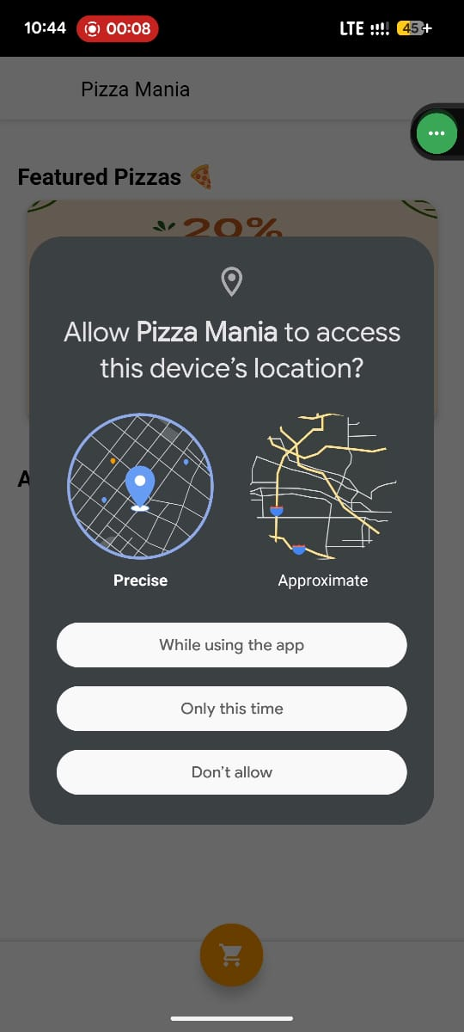

- Effective Staff Management: The staff dashboard successfully segregates orders by branch. The menu availability feature works instantly, with changes made by staff immediately reflected for customers ordering from that branch.
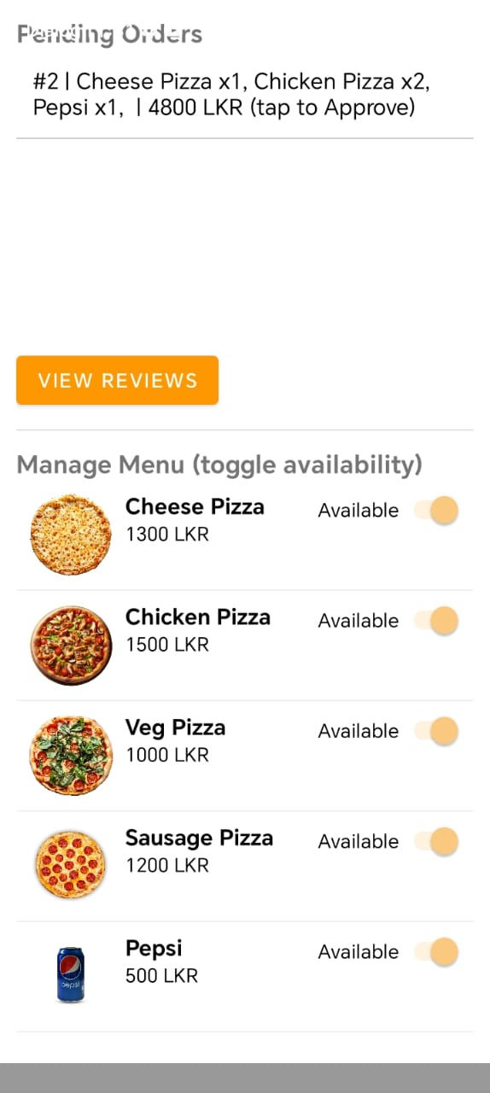

- Robust User Experience: The application provides a smooth and intuitive flow for the customer, from login and menu browsing to placing an order. The auto-sliding banner and clean UI enhance the user experience.

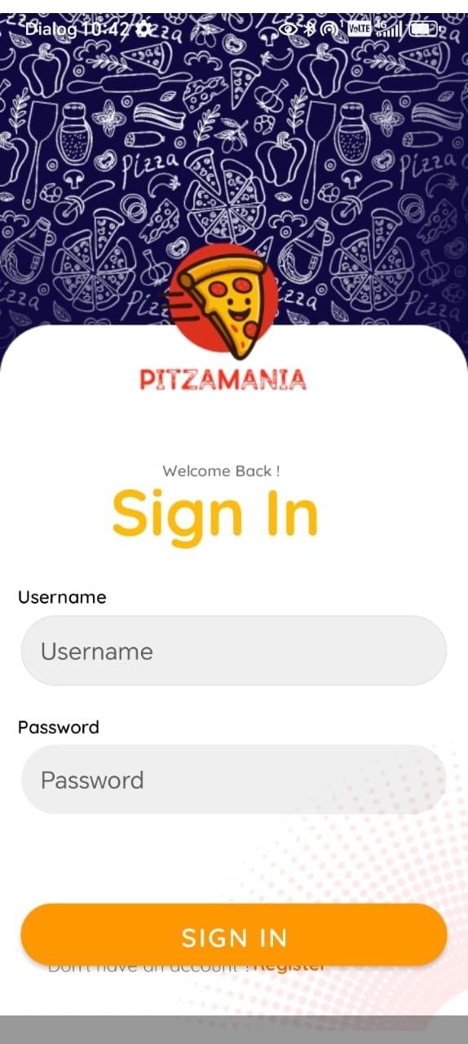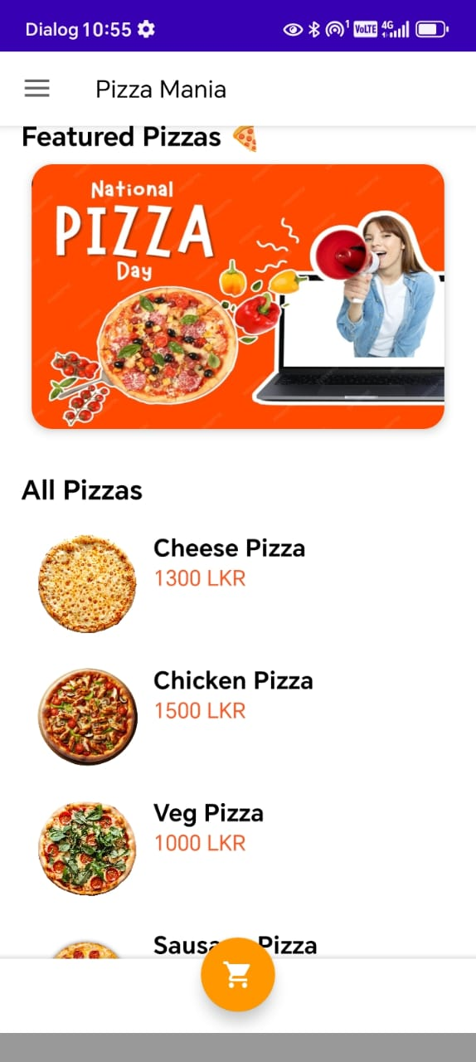

- Successful APK Generation: The application was successfully compiled into an APK with minSdk set to 24, ensuring compatibility with over 96% of Android devices and allowing for successful installation on physical hardware.

05.DISCUSSION.
5.1 Challenges Faced
The following technical issues were faced and resolved during development:
- Layout Problems with Nested Scrollable Views: One major issue in the staff dashboard was that a ListView inside a ScrollView was causing rendering problems (only displaying the first item). This was fixed by re-architecting the layout to use a LinearLayout with layout_weight, which produced a versatile and adaptable user interface that functions on various screen sizes.
- Database State Management: Data inconsistencies (such as missing menu items) were caused by the test device's outdated single-user database when the multi-branch functionality was added. This underscored the significance of fully uninstalling or clearing app data during development to guarantee a new database state following schema amendments.

Database State Management:
- Data inconsistencies (such as missing menu items) were caused by the test device's outdated single-user database when the multi-branch functionality was added. This underscored the significance of fully uninstalling or clearing app data during development to guarantee a new database state following schema amendments.

Real Device vs. Emulator Discrepancies:
- On an actual device with a smaller screen, layouts that looked OK in the emulator occasionally broke. In contrast to fixed-size dp values, this highlighted the necessity of flexible, adaptive layouts (layout_weight, ConstraintLayout).

5.2 Strengths of the Project
Offline-First Architecture: The program is very responsive and can run completely offline (for browsing and viewing history) because all of its essential functionality is implemented in the local SQLite database.
Advanced Database Logic: The project shows a thorough comprehension of database architecture, including table linkages and the application of sophisticated queries such as the Haversine formula for calculating distance.
Full Feature Loop: The application exhibits a thorough comprehension of system design by effectively closing the loop between all three user roles.
06. REFERENCES
1.Android Developer Documentation. (2023). Build a responsive layout with ConstraintLayout. Retrieved from https://developer.android.com/develop/ui/views/layout/constraint-layout

2.Android Developer Documentation. (2023). Saving data using SQLite. Retrieved from https://developer.android.com/training/data-storage/sqlite

3.Firebase Documentation. (2023). Cloud Firestore. Retrieved from https://firebase.google.com/docs/firestore

4.Google for Developers. (2023). Maps SDK for Android. Retrieved from https://developers.google.com/maps/documentation/android-sdk

07.Acknowledgements
We would like to sincerely thank [professor's Name], our professor, for all of their help and assistance during this assignment. We also like to express our gratitude to our fellow group members for their hard work and cooperation.

7. Appendices
Appendix A: Key Code Snippet - Database Seeding
This snippet from DBHelper.java shows how the initial data, including menu items with branch-specific availability, is created.

private void seedInitialData(SQLiteDatabase db) {
// Add Branches
// ... code to add Colombo and Galle branches ...

// Add Menu Items for Colombo (branchId = 1)
addMenuItem(db, "Cheese Pizza", "1300 LKR", 1300, R.drawable.cheese, 1, true);
addMenuItem(db, "Chicken Pizza", "1500 LKR", 1500, R.drawable.chicken, 1, true);
addMenuItem(db, "Veg Pizza", "1000 LKR", 1000, R.drawable.veg, 1, true);
addMenuItem(db, "Sausage Pizza", "1200 LKR", 1200, R.drawable.sausage, 1, false); // Not available
addMenuItem(db, "Pepsi", "500 LKR", 500, R.drawable.pepsi, 1, true);

// Add Menu Items for Galle (branchId = 2)
addMenuItem(db, "Cheese Pizza", "1300 LKR", 1300, R.drawable.cheese, 2, true);
addMenuItem(db, "Chicken Pizza", "1500 LKR", 1500, R.drawable.chicken, 2, false); // Not available
addMenuItem(db, "Veg Pizza", "1000 LKR", 1000, R.drawable.veg, 2, true);
addMenuItem(db, "Sausage Pizza", "1200 LKR", 1200, R.drawable.sausage, 2, true);
addMenuItem(db, "Pepsi", "500 LKR", 500, R.drawable.pepsi, 2, true);
}

Appendix B: Key Code Snippet - Menu Availability Adapter
This snippet from StaffMenuAdapter.java shows how the UI switch directly updates the database.
code
Java
download
content_copy
expand_less
IGNORE_WHEN_COPYING_START
IGNORE_WHEN_COPYING_END
public class StaffMenuAdapter extends ArrayAdapter<StaffMenuAdapter.MenuItemRow> {
// ... constructor ...

@Override
public View getView(int position, View convertView, ViewGroup parent) {
// ... view inflation logic ...

Switch switchAvailable = convertView.findViewById(R.id.switchAvailable);
switchAvailable.setChecked(item.isAvailable());

switchAvailable.setOnCheckedChangeListener((

